External Documentation for Blogging Sie



Table of Contents

1. Description
2. Wireframes
3. Screen Capture
4. Potential Future Functionality

Description

My blogging site allows users to create an account and post a blog entry. Other users will be able to comment on any open blog. Users will be able to see all blogs posted on the right hand side of the site. Users are allowed to close comments to their own blog entries.

Wireframe

Index wireframe

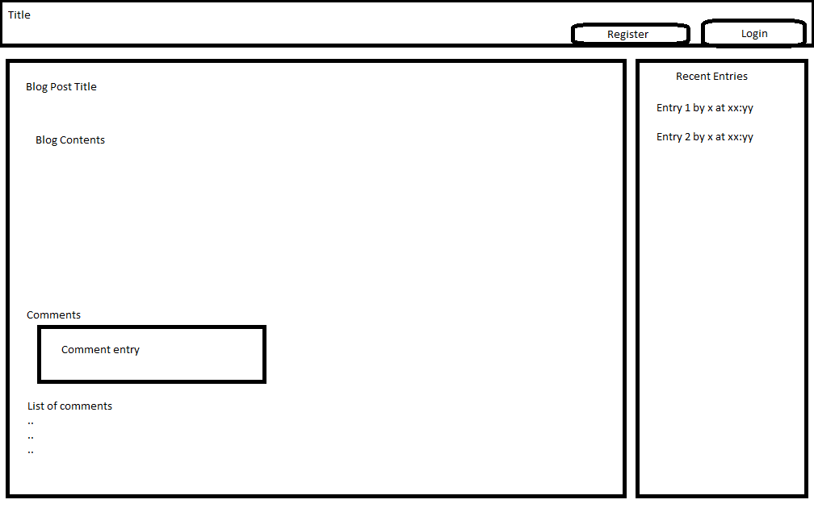

Registration Wireframe

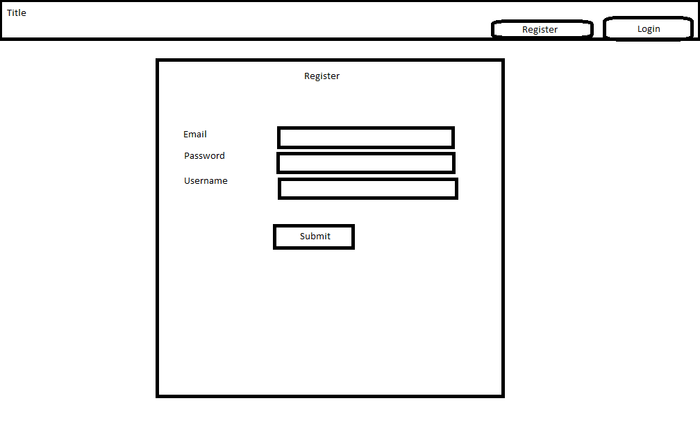

Post Editor (editor.php)

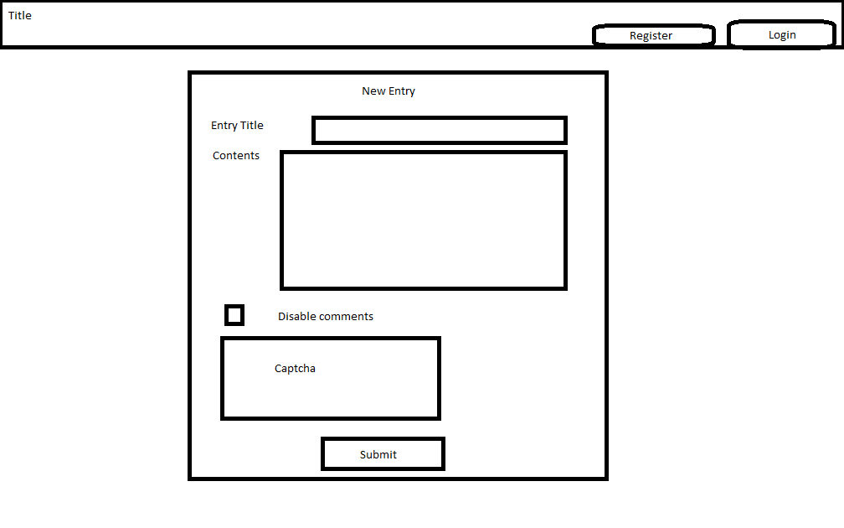

Screen Capture

# Main Page (index.php)

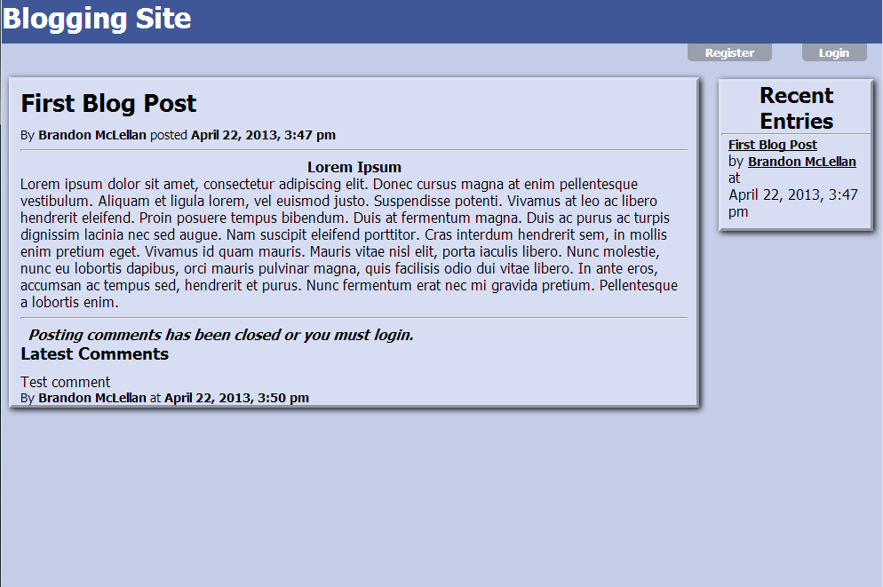

# Registration Page (register.php)

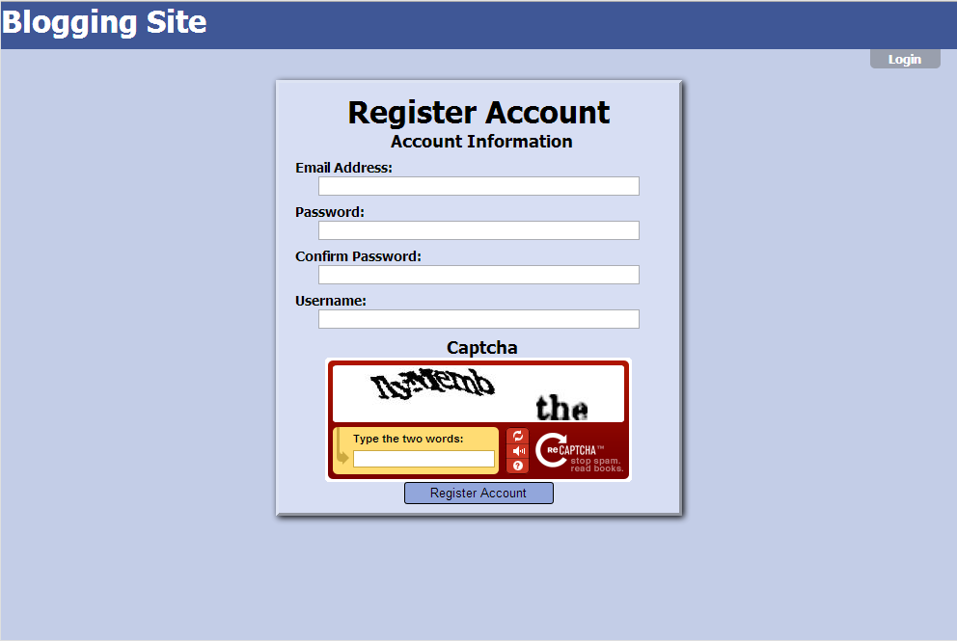

# Blog Posting(editor.php)

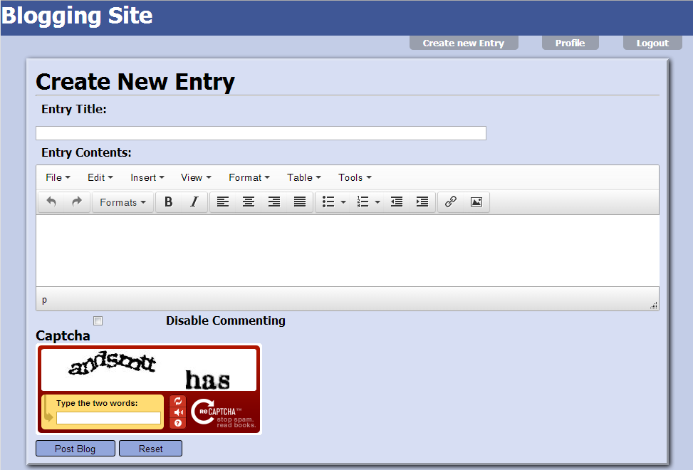

Potential Future Functionality

* Ability to tag blog posts based on content
* Search / filter blog posts based on tags
* Share buttons for Facebook, Google+, etc..
* Administrative functionality (Add/delete users, comments, posts, etc..)